Day 21: 12-11-2025:

1st Eureka Server
To create Eureka Server
Starter Eureka Starter
Starter Web starter

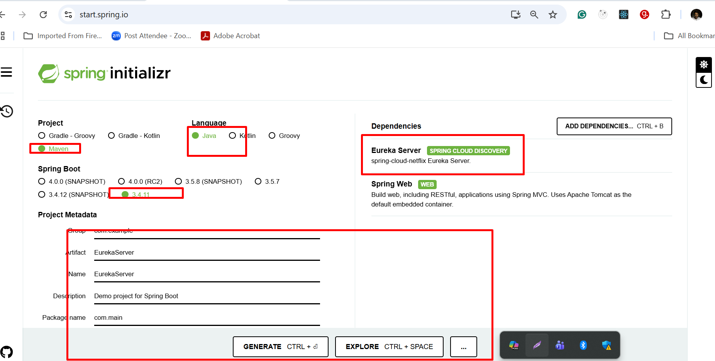

By default each micro service project search eureka server on default port number 8761.

Account Micro Service

1st micro service project port number 8282
Starter Web Starter
Starter JPA starter
Dependency MySQL Connector
Starter Eureka Discovery client

application.properties file
Mysql database connection details

It provide account related end point
Accno PK
Name
Amount
Emaild Unique

Post method account create
Get method find balance using accno with path param
Custom query
Using emailId find the balance
Using emailId find account number

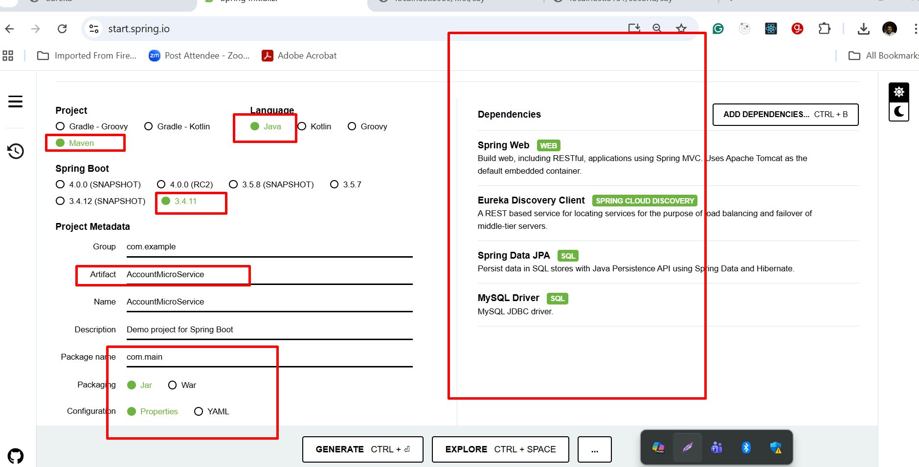

JPQL : Java Persistence Query language
select ac from Account ac; here Account is entity class name and ac is object name.
select ac from Account ac where ac.amount > 12000;
here ac is object and amount is variable name.
seletct ac from Account ac where ac.accNo=100;
SQL
select * from account; here account is table name not a case sensitive and * means all column
select * from account where amount > 12000;
here amount is column name.

Gpay Micro Service
2nd micro service project port number 8383
Starter Web Starter
Starter MongoDB
Starter Eureka Discovery client

application.properties file
Mongo DB database connection details

Gpay - Collection
_id - like Pk make type of String (auto generate)
Accno -
EmailId

Post method passing emailed through body part
This micro service running on port number 8383. Receive emailId and communicate to account micro service to get the accno.
If we pass correct emaild id we get account number or else we get -1.
If account is present we will create gpay account else
To communicate one micro service to another micro service using Java
Get Method : if we pass gpay id using gpay id we will get accno number that account number we will pass to account micro service to get amount (balance amount).
- RestTemplate : it is use to achieve synchronization communication.
- Feign client
- WebClient

Spring boot doesn’t do DI for few API. We need create the object but maintain by spring container.

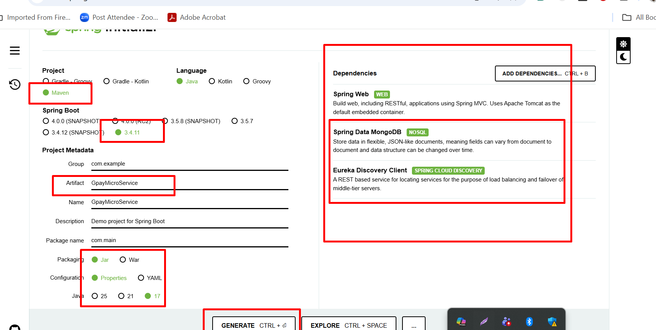

// on rest template creation method

@LoadBalance : this annotation help us to communicate rest api using micro service name rather than IP Address with port number or local machine with port number.
Using this annotation we can scale up and scale down on demand when n number of client increase the access the micro service.

Eureka Server - 8761 port number
Account micro service 8282 port number
Gpay micro service 8383 port number

All these service running on same machine.

These all micro service can be run on different machines.
Central machine
Eureka Server can be run on server machine198.167.12.10:8761

Account micro service-198.15.45.127:8282
In application.properties file we need to write some property ie eureka server ip address and port number.
Scale up means same application can on different port number
9191,9292,9393, 9494 etc.
Gpay micro service 196.67.123.45:8383
In application.properties file we need to write some property ie eureka server ip address and port number.

Running spring boot project using Spring boot CLI(Command line interface)

Open the command prompt or terminal inside a project in the location mvnw and run the run the command as
mvnw spring-boot:run

for each micro service project
using mvn command create the file (command prompt must be inside a project folder ie pom.xml)
ie mvn package (it create filename.jar )
cd move inside a target folder
java -jar jarfilename.jar --server.port=9090

API Gate way
API Gate way is a like a front controller or entry door for all micro service project. Rather than providing each micro service details to frontend technologies or rest api or post man client we can provide Api Gate way application URL or host name port number.
It receive each client request, and routes base upon their path it particular web service and return the response. While passing request and response if you need they can filter it.

API gate way concept version to version different type of starter added in spring boot.
- Old version Netflix Zuul module : olde version
- Spring cloud gateway : new version

First we need to create the spring boot api gateway project.
Starter API gate way (Reactive API Gateway)
Starter -> Eureka Discovery client

API Gateway port number : 8080

API gateway configuration we can write inside
application.properties file
application.yml file
we can write in normal java classes.

